|  |  |  |
| --- | --- | --- |
|  |  | **School Newsletter 31st October 2023 2023** |
| **Ltyentye Apurte Catholic School**  Church Street, Santa Teresa, PMB 221, Via Alice Springs, NT, 0872.  Telephone: (08) 8956 0937 email: robert.dreise@nt.catholic.edu.au |

Dear Families,

**All Souls Mass**

All Souls Day Mass will be held this Thursday, 2nd November at 9:30am. The mass will be held at the cemetery for the whole school and family members who wish to attend. Staff and students will walk to the cemetery and younger students will take the school bus. The setting is under the large shady at the cemetery. Students will prepare flowers to place on the graves and community members are invited to bring flowers as well.  After Mass, the graves are blessed, and families receive a blessing with holy water. It will be a special day for the school and the parish.

We had many visitors to our school last week for the SMART launch. We had pleasure in welcoming Arrernte elder Dr Jenni Caruso, her son Pat Caruso and his family. Vice President of SMART, Jeff Lowe presented our school with the SMART Exemplary School Award and staff member Marcus Williams with the SMART Ambassador Award. We also welcomed Rebecca Woolnough and Daniel Wicks who helped with the presentation of computer programs. I am told that our school featured on Channel 9 news.

**Other News**

|  |  |
| --- | --- |
|  | Our school had a visit by the National Evangelisation Teams (NET TEAM) last week. The NET team is a group of young Catholics (youth ministry) who work with our students to put into action the Church's mission to proclaim the Gospel of Jesus Christ. The team helps teachers with their religious education and encourages students to live the live that God intends. |
|  | A reminder that our school is closed before 7:45am. Breakfast will be served at 8:00am so we ask that students come just before that. A big thank you to Tony our Chef and Brother Francis for preparing and serving breakfast. Thanks also to Larissa for helping to prepare morning tea and lunch for the students. |
|  | Ltyentye Apurte welcomed many guests to our community to help celebrate the 70th Anniversary. A sincere thank you to staff and students who helped make the occasion a success. A photo display is still set up in the school library if community members would like a final look before it is taken down Wednesday morning. |
|  | As in previous years, students who are enrolled and have attended school for more than 30 days, will receive a Christmas hamper at the end of the term. We are excited about organising Bethlehem Road at the end of the year as we all celebrate this special time as a school community. |
|  | This week, our Arrernte Language and Culture Team will travel to Darwin to participate in a bilingual professional development. |
|  | **A warm welcome to Cameron Solly (CC) who is our new property manager. CC will work with Nathaniel and Warwick to keep our school grounds well maintained. Welcome CC.** |
| [This Photo](https://www.wisc-online.com/asset-repository/viewasset?id=1276) by Unknown Author is licensed under [CC BY-NC](https://creativecommons.org/licenses/by-nc/3.0/) | **Tuesday October 31st**  Blue Earth Games Visit  Arrernte Language and Culture Staff to Darwin for Professional Development  **Wednesday November 1st**  All Saints Day  Swimming Lessons  **Thursday November 2nd**  All Souls Mass 9:30 at the Cemetery  Sport and Well-being Program  Land Council Meeting 3pm Basketball Court  Swimming Lessons  **Friday November 3rd**  Swimming Lessons |
|  | Our school is part of the Parish community. We value and respect the role of the Parish Priest and the presence of the Marist Brothers. Marists believe that the Catholic school is a most effective place to ensure our students are given a solid grounding in their faith. We are part of a Catholic Community that has a rich faith tradition introduced into the Church by St Marcellin Champagnat. Kathy and I were fortunate enough to be invited to the Marist Schools Australia Conference mass and dinner where we had the pleasure of meeting past principal Brother Daniel Hollamby. Brother Daniel sends his regards to the Ltyentye Apurte Community. He reflected on his time here with fond memories. |

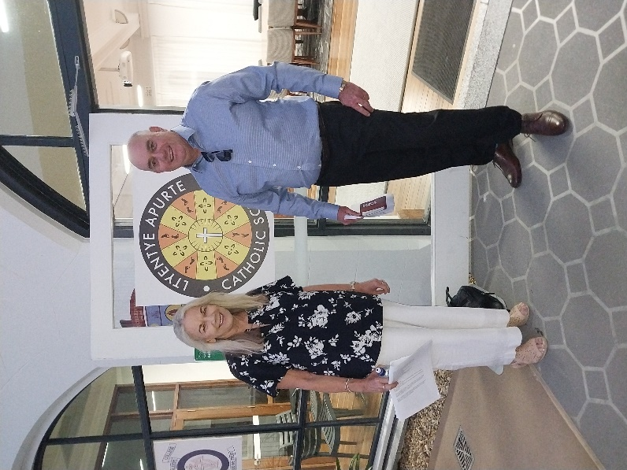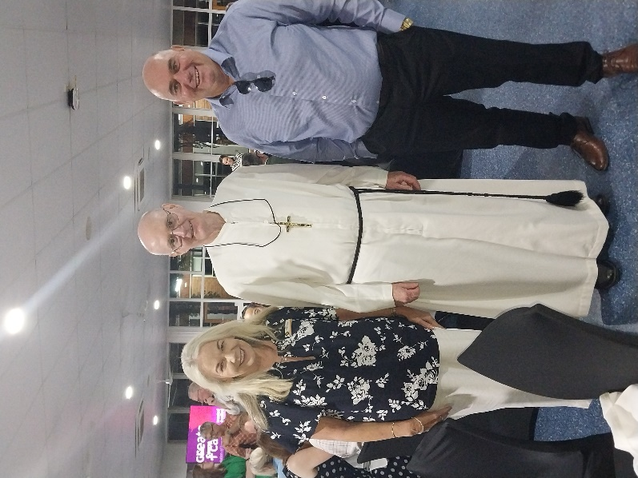

LACS Past Principal

Brother Daniel Hollamby

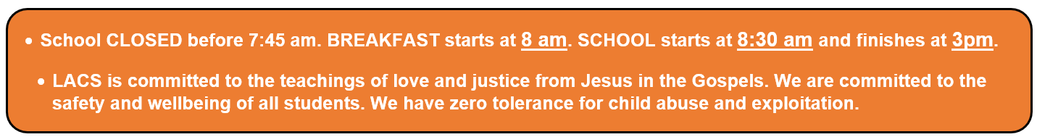

Mr. D

Principal

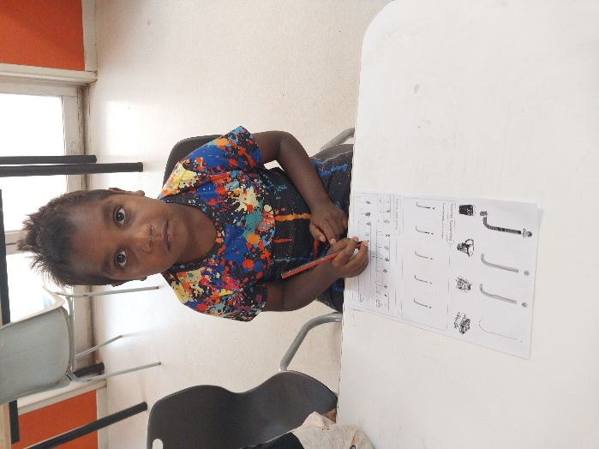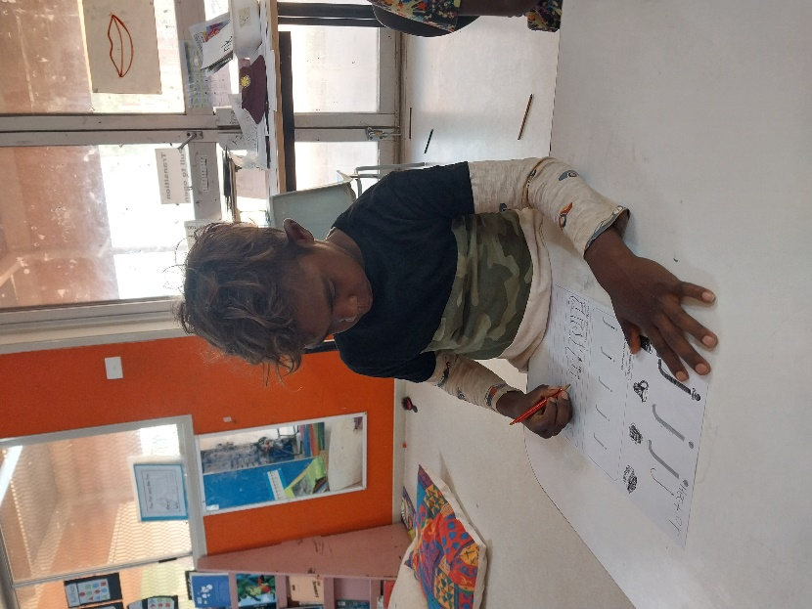

**J 1**

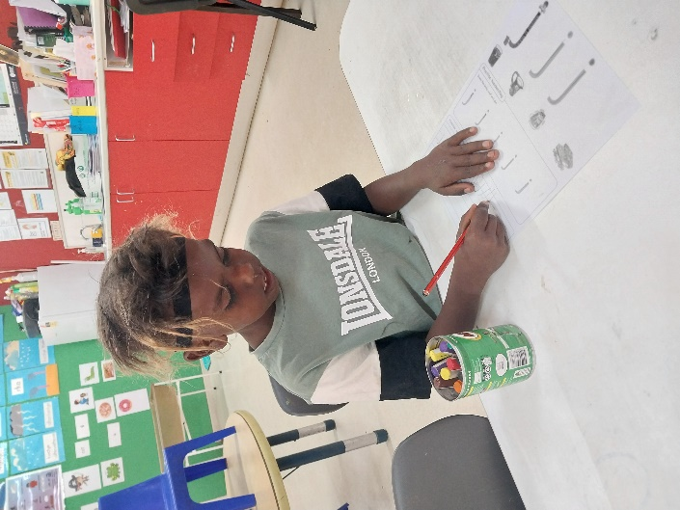

**Junior 1**

**class**

**working hard**

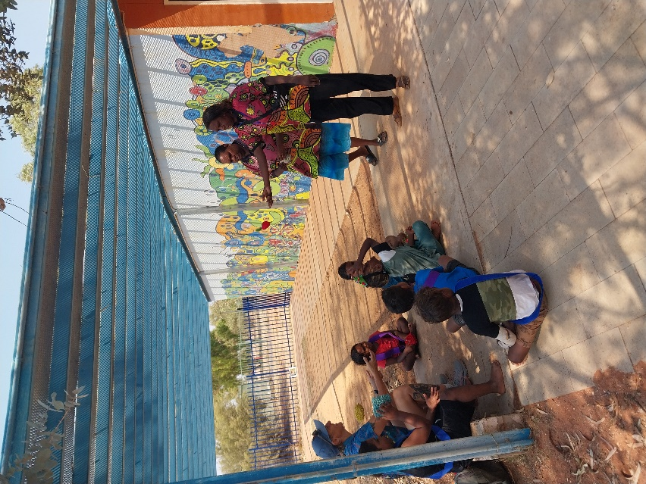

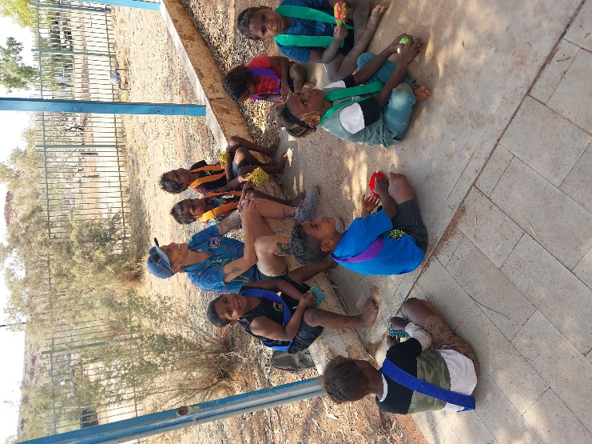

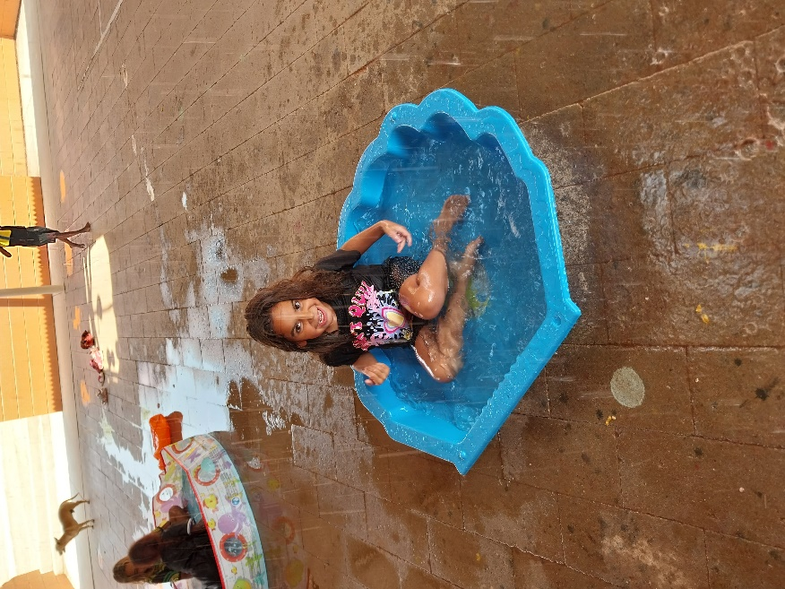

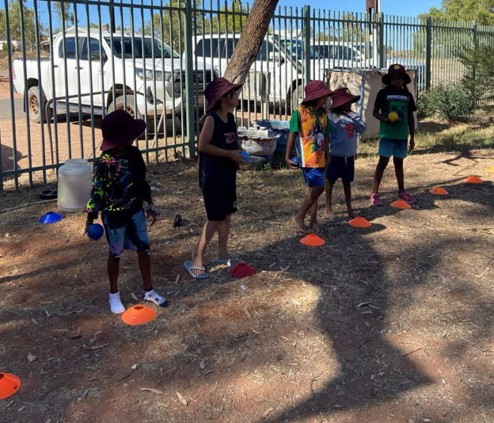

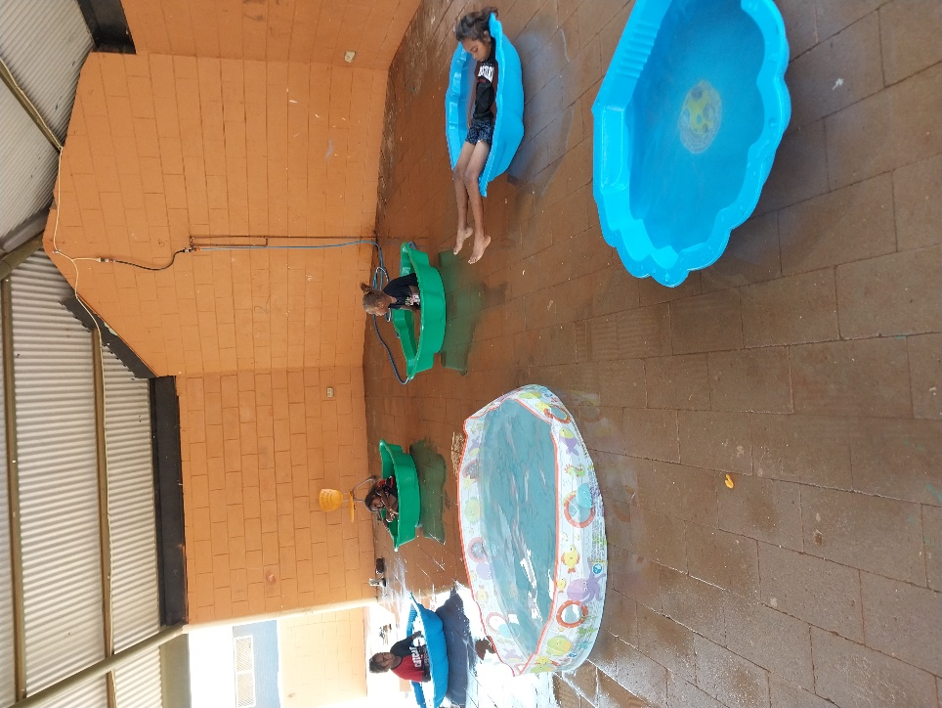

**Junior 2**

**Class**



